Monica Araya

Advocate, Adviser & Communicator

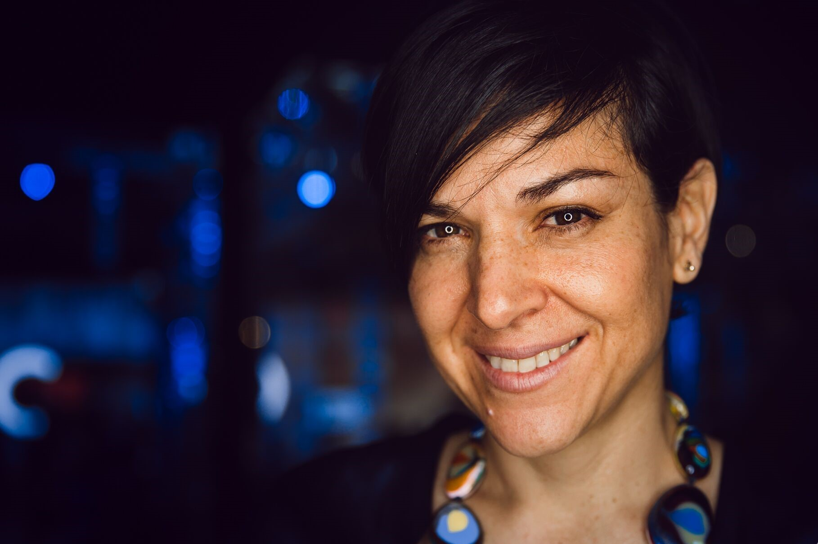

Monica Araya is an advocate, adviser and communicator who has incubated several initiatives in Latin America. She founded Costa Rica Limpia (costaricalimpia.org) to bring people closer to clean, smarter technologies that improve their everyday life. Her work focuses on consumer and citizen engagement in the shift toward renewable energy and zero emissions electric mobility. Her group pioneered www.movilidadelectrica.org – the first electric mobility platforms in Latin America devoted to the education of consumers about electric vehicles. She also co-founded the Electric Mobility Association in Costa Rica and is Vice President of the Board. Her blog, “Essentially Electric” is hosted at the business newspaper La República. She writes frequently for international and local media and has given talks in Latin America, Europe and Asia. Her TED talk fossil-free Costa Rica that has over one million views and has been translated into 30 languages. In 2017 she was mentor to the Next Visionaries, a TED & BMW’s initiative about the future of mobility. In December 2016, she joined the world´s largest all-female expedition to Antarctica and was the first Latin American member of this global “women in STEM” leadership network. The French Ministry of Foreign Affairs named her “Personality of the Future”. Her work has been mentioned TIME magazine, the Financial Times, Hindu Times, The Independent, National Geographic, El País, Repubblica, and The Guardian. Her articles and videos are available at www.monicaaraya.org Twitter @MonicaArayaTica
Additional information:
- She has done extensive work on climate politics with a focus on Latin America. She was a negotiator for Costa Rica in the international climate negotiations. In the road to Paris (COP21) she launched www.nivela.org to promote new voices in support of climate action.
- She is Policy Adviser at E3G since 2009
- Senior Associate at the Cambridge Institute for Sustainability Leadership since 2016.
- She has been an independent consultant to many organizations including the OECD, WRI, ODI, NREL, ECF, Climate Works, CDKN, INCAE-Business School, Estado de la Nación-Costa Rica and the United Nations. Environmental Law & Policy and worked at the Ministry of Foreign Trade in Costa Rica and Climate Change Capital in London.
- She is a board member and/adviser to of several initiatives including the UNEP Emissions Gap Report 2012-2017 and the Climate Vulnerability Forum. She co-chaired the Platform for Low-Emissions Development Strategies in Latin America and the Caribbean. She was a WEF Global Agenda Council member in 2015-2016. She is a member of the Advisory Board of “State of the Union” – the most authoritative annual review of the state of Costa Rica and of the magazine of environmental sciences in Costa Rica (Revista de Ciencias Ambientales).
- Monica has a Ph.D. from Yale University and prior to that she got her Masters, also at Yale, and a masters in economic policy at UNA in Costa Rica. Her studies have focused on the nexus between economic development and environmental protection.

